|  |  |
| --- | --- |
| *Pacific Gas and Electric Company* | |
| Release 9.3.1B Installation Guide | |
|  |  |
|  |  |
| Project | ED AM/GIS |
|  |  |
| Prepared by | Roger Carribine |
| Date | 2/4/2015 |
| Version | 1.0 |
| Version Type | In Progress |

|  |  |  |  |
| --- | --- | --- | --- |
| Revision History | | | |
| Document # | Date | Author | Summary of Changes |
| 1.0 | 4th Feb 2015 | Roger Carribine | Initial Document Creation |

# Introduction

## Purpose

This document is intended to detail the implementation and configuration steps required to implement Release 9.3.1B Installation Guide. This document describes the various configuration aspects required to complete any manual or automatic patch associated with this release. Each section in this document contains the steps required to patch the system in production.

## Terms Used

|  |  |
| --- | --- |
| OOTB | Out of the box. Unmodified from the commercial version. |
| TFS | Team Foundation Server |

## External Documents

Referenced are any external configuration documents or exports. These are documents that contain more detailed information about configuring a system or documents that can be loaded into an application to perform the configuration detailed in this document.

1. Trans Unit Python scripts location:
   1. \\sfetgis-nas01\sfgispoc_data\ApplicationDevelopment\IBM_Delivery\ReleaseInstructions\9.3.1\Python scripts
2. Privileges script location:
   1. \\sfetgis-nas01\sfgispoc_data\ApplicationDevelopment\IBM_Delivery\ReleaseInstructions\9.3.1

## List of Fixes

Below is the list of change requests detailing all fixes for the data model for this release:

|  |  |
| --- | --- |
| **Item Number** | **Title** |
| **19112** | Master TFS Data Model 9.3.1B |
| **19129** | **Apply ESRI_SPLITWITHUPDATE model name to Conduit** |
| **19133** | **Modify SupervisoryControl field on Switch:Overhead Disconnect** |
| **19137** | **Remove AAA_ANNO_UPDATES table** |
| **19139** | **50 Scale Annotation Automatic Placement** |
| **17271** | **Change GEMS-related field aliases in Pre-Prod** |
| **19141** | **Snapping Antenna to support structure** |
| **19145** | **Primary Voltage Domain description** |

## Summary of Steps to Complete Install

Contents

1 Introduction 3

1.1 Purpose 3

1.2 Terms Used 3

1.3 External Documents 3

1.4 List of Fixes 4

1.5 Summary of Steps to Complete Install 5

2 Open a Database Connection in ArcCatalog 6

3 TFS19129 Apply ESRI_SPLITWITHUPDATE model name to Conduit 7

4 TFS19133 Modify SupervisoryControl field on Overhead Disconnect Switch 8

5 TFS19137 Remove AAA_ANNO_UPDATES table 9

6 TFS19139 50 Scale Annotation Automatic Placement 10

7 TFS17271 - Change GEMS-related field aliases in Pre-Prod 13

8 TFS19141 - Snapping Antenna to Support Structure 14

9 TFS19145 Primary Voltage Domain Decription updated to match production domain. 15

10 TFS19144 - Populate the polgon to cover central valley in webr 16

11 Data Model Version Table 17

12 Known Issues 18

# Open a Database Connection in ArcCatalog

1. Open ArcCatalog.
2. Within the Catalog Tree, expand “Database Connections” and open the active connection for this process. This is the connection that is referenced in the change request associated with this document (EDGIS<DB name in the format X#Y> )

# TFS19129 Apply ESRI_SPLITWITHUPDATE model name to Conduit

1. Right click on the **ConduitSystem** feature class in the Electric dataset and select **ArcFM Properties Manager**
2. Select the **Model Names** tab
3. Select the **PGE ED Object Class Model Name** domain from the Model Name Domain drop down
4. In the Available list, select the **ESRI_SPLITWITHUPDATE** model name and move it to the list of Selected model names

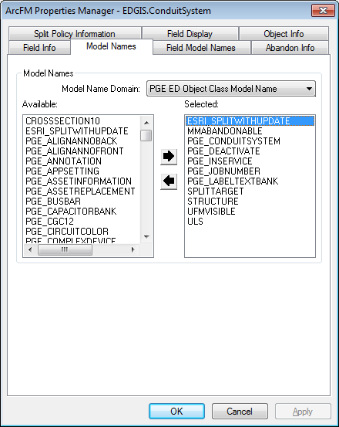

1. Click **OK**

# TFS19133 Modify SupervisoryControl field on Overhead Disconnect Switch

1. Right-click on **Switch** in the Electric dataset and select **ArcFM Properties Manager**
2. Select the **Field Info** tab
3. Select the **Overhead Disconnect** subtype
4. Select the **SUPERVISORYCONTROL** field
5. Modify the **Allow NULL Values** field to **Yes**

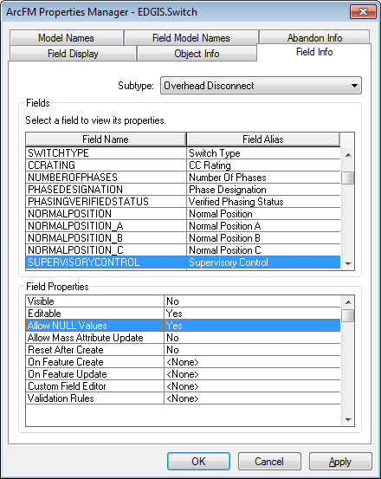

1. Click **OK**

# TFS19137 Remove AAA_ANNO_UPDATES table

1. Right-click on the **AAA_ANNO_UPDATES** table in the root and select **Delete**
2. Select **Yes** to confirm the delete

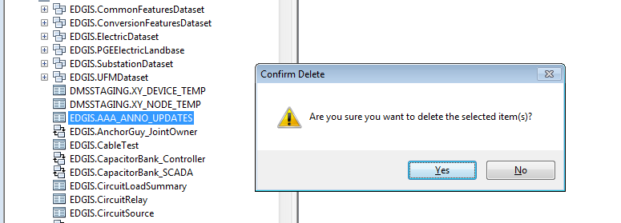

# TFS19139 50 Scale Annotation Automatic Placement

1. Right-click on **ConduitSystem50Anno** in the Electric dataset and select **Properties**
2. Select the **Annotation** tab
3. Uncheck the checkbox entitled **Update annotation when feature’s shape is modified**

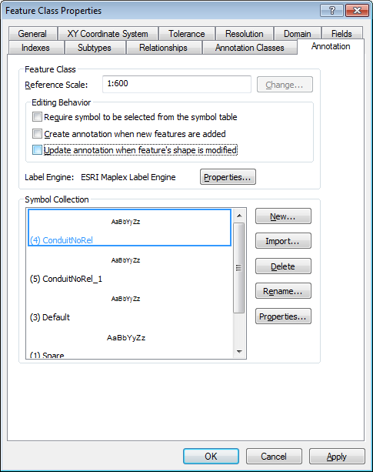

1. Click **OK**
2. Repeat steps 1 through 4 for the following annotation feature classes:

* DCConductor50Anno
* NeutralConductor50Anno
* PriOHConductor50Anno
* PriUGConductor50Anno
* SecOHConductor50Anno
* SecUGConductor50Anno

1. Right-click on **CapacitorBank50Anno** in the Electric dataset and select **Properties**
2. Select the **Annotation** tab
3. Uncheck the checkbox entitled **Create annotation when new features are added**
4. Uncheck the checkbox entitled **Update annotation when feature’s shape is modified**

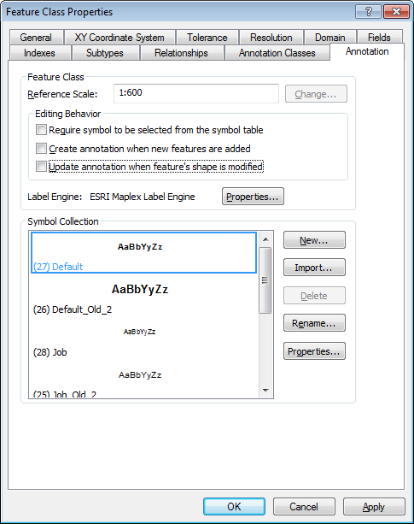

1. Click **OK**
2. Repeat steps 6-10 for the following annotation feature classes:

* CustAgreeNumber50Anno
* DCDevice50Anno
* DCRectifier50Anno
* DeliveryPoint50Anno
* DeviceGroup50Anno
* DistBusBar50Anno
* DynProtDevice50Anno
* FaultIndicator50Anno
* Fuse50Anno
* JobNumber50Anno
* NetworkProtector50Anno
* PrimaryGeneration50Anno
* SecondaryGeneration50Anno
* StepDown50Anno
* StreetLight50Anno
* Substation50Anno
* SubsurfaceStructure50Anno
* Switch50Anno
* Transformer50Anno
* VaultPoly50Anno
* VoltageRegulator50Anno

# TFS17271 - Change GEMS-related field aliases in Pre-Prod

1. Open ArcCatalog
2. Select the CapacitorBank featureclass
3. Right Click and select properties
4. Select the fields tab
5. Select the Field: GEMSDISTMAPNUM
6. Set the Alias to: MET Distribution Map #
7. Select the Field: GEMSCIRCUITMAPNUM
8. Set the Alias to: MET Circuit Map #
9. Select the Field: GEMSOTHERMAPNUM
10. Set the Alias to: MET Other Map #
11. Repeat steps 2-10 for each of the following Feature Classes.
    1. DCRECTIFIER
    2. DYNAMICPROTECTIVEDEVICE
    3. FAULTINDICATOR
    4. FUSE
    5. LOADCHECKPOINT
    6. OPENPOINT
    7. PRIMARYMETER
    8. SECONDARYLOADPOINT
    9. SERVICELOCATION
    10. SERVICEPOINT
    11. SMARTMETERNETWORKDEVICE
    12. STEPDOWN
    13. STREETLIGHT
    14. SWITCH
    15. TIE
    16. TRANSFORMER
    17. TRANSFORMERDEVICE
    18. VOLTAGEREGULATOR

# TFS19141 - Snapping Antenna to Support Structure

1. Open ArcCatalog
2. Connect to the database to be updated.
3. Select the Antenna featureclass in the ElectricDataset
4. Right Click and choose ArcFM Snapping Manager
5. In the available feature classes select Support Structure
6. Hit the Down Arrow to set it in the Snapping Targets.
7. Set the Snapping Tolerence to 10.
8. Uncheck edge and end, as in the screenshot below.

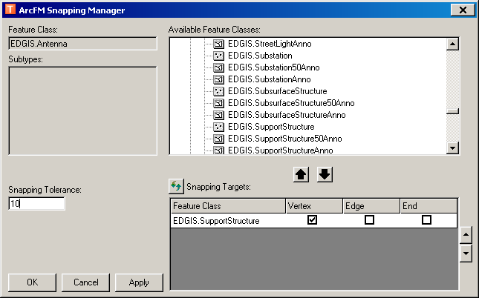

# TFS19145 - Primary Voltage Domain Decription updated to match production domain.

Alter the Primary Voltage domain to reflect the following:

|  |  |  |
| --- | --- | --- |
| Code | Description |  |
| 0 | 480V |  |
| 1 | 2.4kV |  |
| 2 | 4.16kV |  |
| 3 | 4.8kV |  |
| 4 | 7.2kV |  |
| 5 | 12kV |  |
| 6 | 17kV |  |
| 8 | 21kV |  |
| 7 | 22kV |  |
| 65 | 19.9kV |  |
| 9 | 44kV |  |
| 85 | 34.5kV |  |

1. Open ArcCatalog

2. Connect to the database to update as the edgis user

3. Right Click on the connection and select properties

4. Select the Domains tab

5. Select the Primary Voltage domain from the list

6. Change the bottom half of the list to have the descriptions and codes match the above requested settings.

# TFS19144 - Populate the polgon to cover central valley in webr

1. Copy the following to c:\temp on your local machine: "\\sfetgis-nas01\sfgispoc_data\ApplicationDevelopment\IBM_Delivery\Releases\WEBR\EDVIEWER_v3.5.0\Central_Coast_Polygon.gdb"
2. Open ArcCatalog and copy the feature class in the filegdb to the Common Features Dataset.
3. Run the Privileges Script to assign privileges on all objects in the gold database. Check section 1.3 for location.

# Data Model Version Table

**Database Configuration:**

1. Open SQL Plus.
2. Log in using the same server and user as was used in section 2.  
     
   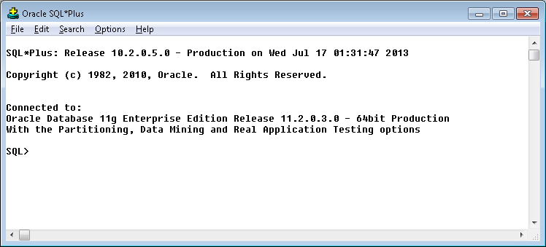
3. Run the SQL below:

update pgedatamodelversion set currentidc='N' where currentidc='Y';

insert into pgedatamodelversion (OBJECTID, CURRENTIDC, DATEAPPLIED, APPLIEDBYPERSONNAME, MODELVERSION) values (**INSERT NEXT VALID ID**,'Y',sysdate,'**<INSERT TEAM MEMBER DONE BY>**','**9.3.1B** GOLD **CR19112**');

commit;

# Known Issues

<Please List any other issues encountered here while following the document>